Task :

Take a screenshot with [Android Studio](https://developer.android.com/studio) set up and the <https://github.com/twilio/twilio-video-app-android> Android SDK Ahoy! Demo App loaded. Taking screenshots as you go, launch the emulator, join a group room, and join the room created by the android app from your browser using the <https://github.com/twilio/twilio-video-app-react> JS SDK Ahoy! Demo App. Post SIDs and screenshots to the GitHub Document.

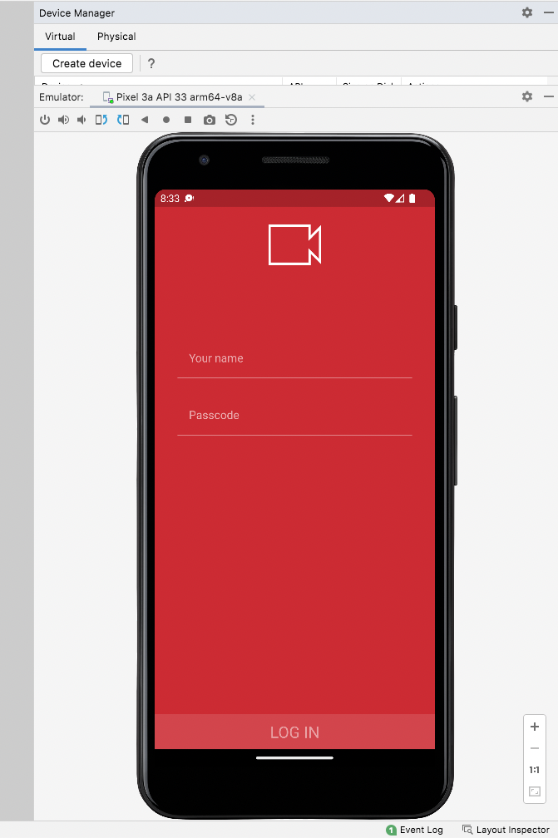

++++++++++++++++++++++++++++++++++

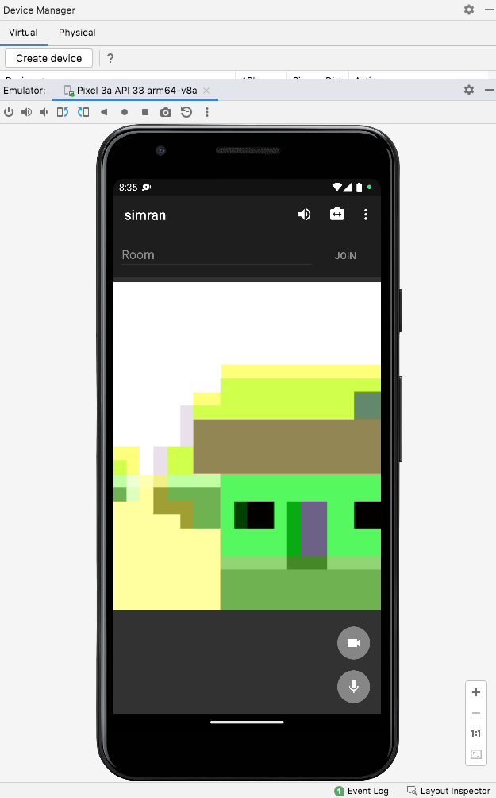

++++++++++++++++++++++++++++++++++++++++++++

Joining Room - sim

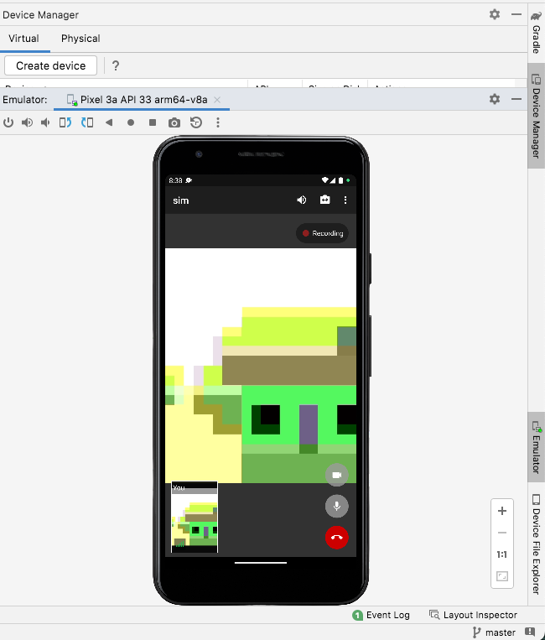

++++++++++++++++++++++++++++++++

Connecting Twilio Video React with Room sim :

Room SID : RM9b22e92f791ff8f473c390191c878e24

